SAP - 1 computer

Contributors
- S.M.B.G. Janakantha
- A.M.N.C. Bandara
- G.S. Seneviratne
- D.H. Sriyarathna
Supervisor
- Dr. Kamalanath Samarakoon

Table of Contents
Introduction 3
Design Procedure 4
Modules 4
Clock Module 5
Program Counter 7
Arithmetic and Logical Unit 8
Output register 9
RAM 9
Control Sequencer 9
Control Signals 10
Printed Circuit Board 10
Budget 11
Assembly Language Instructions: 12
Results 12
Conclusions and Future Works 12
References 12

Introduction
“SAP” is the shortened form of “Simple As Possible”. SAP-1 is the first stage in the evolution of modern computers which seems more complex and multitasking. This particular design includes somewhat elevated functions than a basic SAP-1 and the functionalities appear in this model will cover many advanced concepts in Computer Architecture.
SAP -1 is a bus-organized (single 8-bit bus through tri-status buffers) computer.
Specification:
- 8-bit Bus
- 4-bit Program Counter
- 4-bit Memory Address Register (MAR)
- 16-byte Memory
- 8-bit Instruction Register (IR)
- 6-cycle micro-instructions with 16-bit words
- 8-bit Accumulator
- 8-bit B register
- 8-bit Output Register
- Arithmetic and Logical unit (ALU)
  - Full Adder / Subtractor
  - XOR
  - AND / NAND
  - OR / NOR

Design Procedure

Modules
All the modules were designed separately designed, fabricated and finally printed them in a single PCB after implementing the connections.
- Clock module
- Program Counter
- Registers
  - Register A
  - Register B
  - Instruction Register
- Arithmetic and Logical Unit (ALU)
  - Full Adder/Subtractor
  - AND / NAND
  - OR / NOR
  - XOR
  - MUX
- Output register
- RAM
- Control sequencer

Clock Module
The computer’s Clock Module is used to synchronize all operations (there are some asynchronized operations within some modules, eg: ALU, even though most of the control instructions were synchronized).
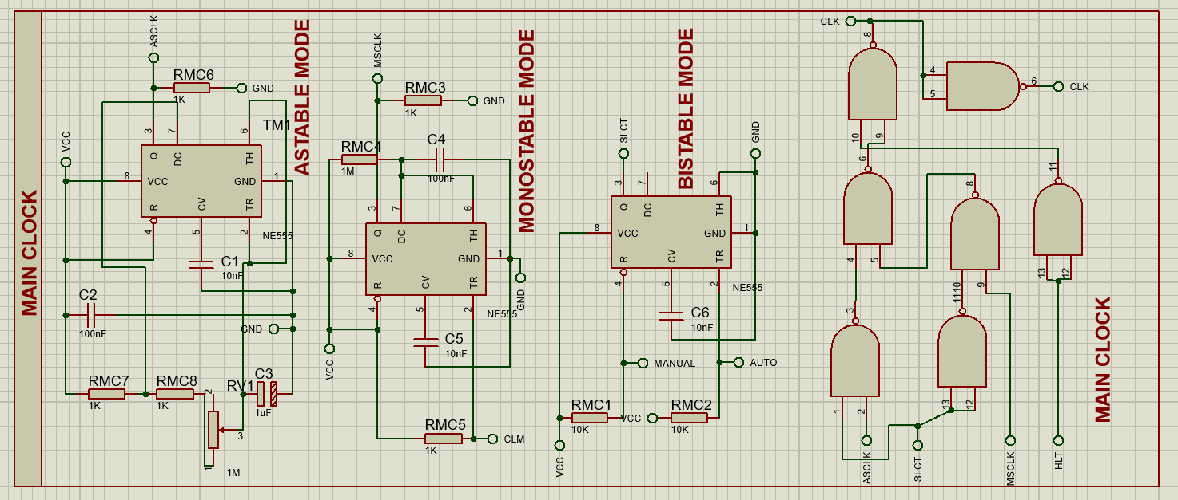

There are two main modes in a clock module.

- A-stable mode
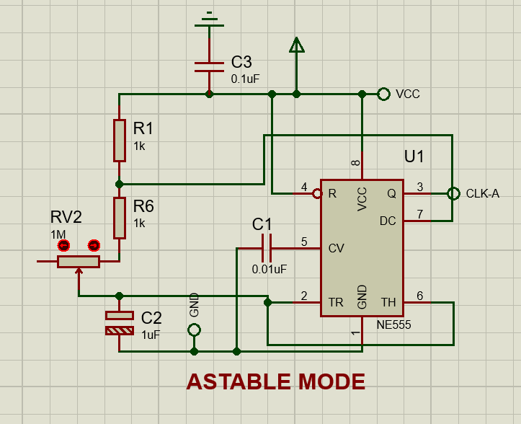
Figure 1- A-stable mode design
In astable mode, a clock module or multivibrator does not have any stable states. Instead, it continuously oscillates between two states, generating a periodic waveform (usually square).
- Behavior: The circuit continuously switches between high and low states without any external trigger.
- Output: Produces a continuous square wave signal.
- Application: Used for generating clock pulses, timing signals, and waveform generation.
A 555 timer IC configured in astable mode will produce a continuous square wave signal, which can be used as a clock signal for digital circuits.
- Mon stable mode
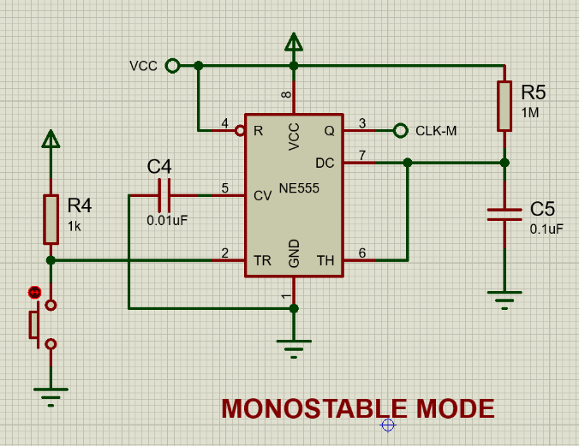
Figure 2 - monostable mode
In monostable mode, a clock module or multivibrator has one stable state and one unstable state. When triggered by an external signal, it temporarily switches to the unstable state and then returns to the stable state after a predetermined period.
- Behavior: The circuit stays in the stable state until it receives an external trigger. After being triggered, it switches to the unstable state for a specific duration before returning to the stable state.
- Output: Generates a single pulse of a defined width when triggered.
- Application: Used in timing applications where a single output pulse is required, such as timers, delay circuits, and pulse width modulation (PWM).
A 555 timer IC configured in monostable mode will generate a single output pulse of a specified duration when triggered, useful for creating time delays or single-shot pulses.

- Bi stable mode
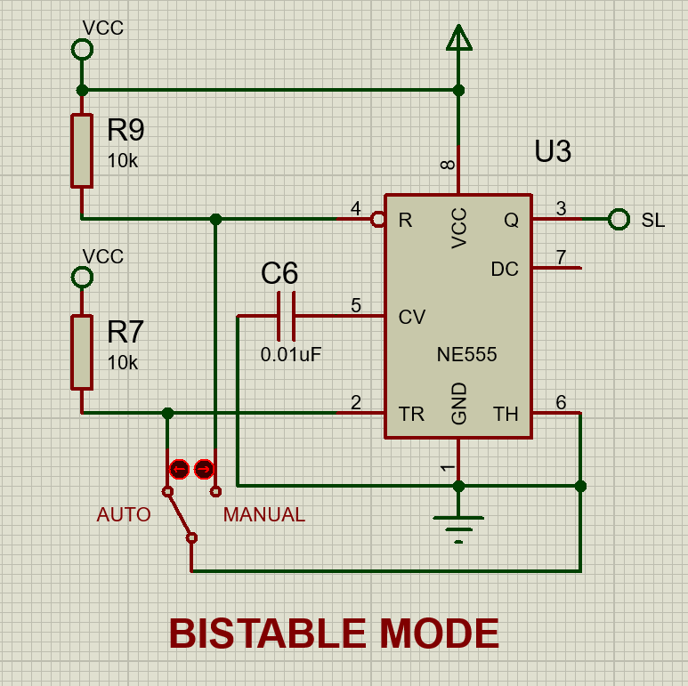
Figure 3 -Bistable mode
In bistable mode, a clock module or multivibrator has two stable states. The circuit can switch between these states based on external inputs and will remain in either state indefinitely until an input causes it to switch.
- Behavior: The circuit remains in one of two stable states until an external input triggers a change to the other state.
- Output: Maintains a stable high or low output until an input causes a state change.
- Application: Used in applications requiring memory storage, such as flip-flops, latches, and data storage elements in digital circuits.
Halt status
To halt the computer programmatically, the halt state can be used. Normally the halt input is a low state and it is inverted by a NOT gate

Program Counter
The program is stored in the RAM as listed instructions. To execute them, the instructions must be fetched from the RAM. So, the program counter is used to keep track of which address is where. It contains the address, or the location of the instruction being executed at the current time.
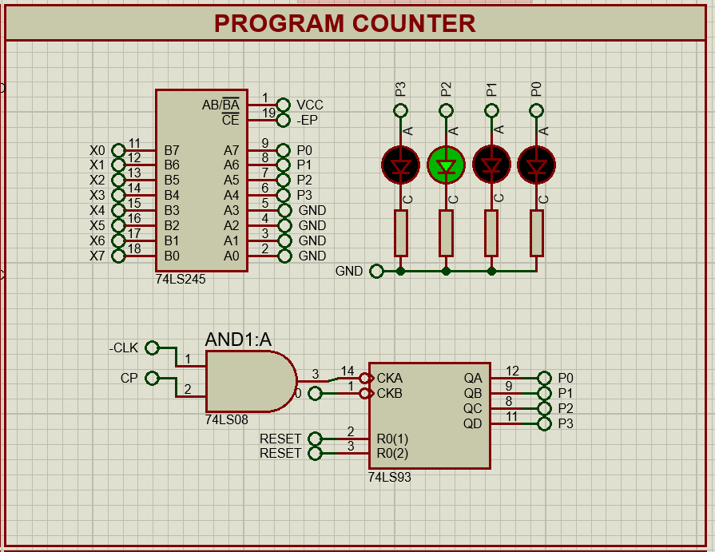
This is a 4-bit counter as the memory has a 4-bit address. This works similarly to register A or register B because it stores a value, and sends and receives values from the bus. The program counter contains 3 control signals.
- Program count out (CO)​: Sends the stored value to the bus
- Jump (Program counter in)​: ​Normally the program counter counts in order from 0. This signal is used to jump around or to run a loop. When the jump signal is enabled it takes the 4 least significant bits from the bus (as this is a 4-bit program counter) and puts it to the program counter. That will be the next address that will be executed.
- Count enables (increment)​: ​To increase the program counter once per instruction cycle, not per clock cycle (because the instruction might take multiple clock cycles). When this is enabled program counter will increase on each clock cycle. So, this signal is enabled to take the next instruction (increase the counter value) and then the signal is disabled (store and doesn’t continue the increment while executing that instruction until the next instruction).
74LS161 was used as a synchronous 4-bit binary counter. This chip gives the ability to control the “jump signal” by the “load pin 9” and “count enables signal’ by the “enable pins 7 and 10”. But to the “program counter out signal” a tri-state-logic interface is needed for the bus. So, it can control whether the output of the chip is the same as the value that goes to the bus. For that 74LS245 is used which has tri-state buffers that allow enabling or isolation.

Arithmetic and Logical Unit
SAP-1 is capable of doing below arithmetic and logical operations.
  - Full Adder/Subtractor
  - AND / NAND
  - OR / NOR
  - XOR
  - MUX
- Components and Architecture

Output register

RAM

Control Sequencer
The Control Sequencer is responsible for managing all other modules in the SAP-1 computer. It receives instructions from RAM and uses an internal ring counter to execute five microinstructions independently. Besides generating control signals, the sequencer includes a reset switch that clears all memory elements, effectively resetting the computer. The Control Sequencer is composed of two parts: one module features pre-programmed EEPROM to produce control signals based on specific instructions and microinstructions, while the second module inverts control signals if the target module operates on an active-low condition. Additionally, it serves as an indicator for control signals.
I have to find out a way to keep moving forward while opening new doors and new opportunities. There is nothing to worry about everything will be find at the end

Control Signals

Printed Circuit Board
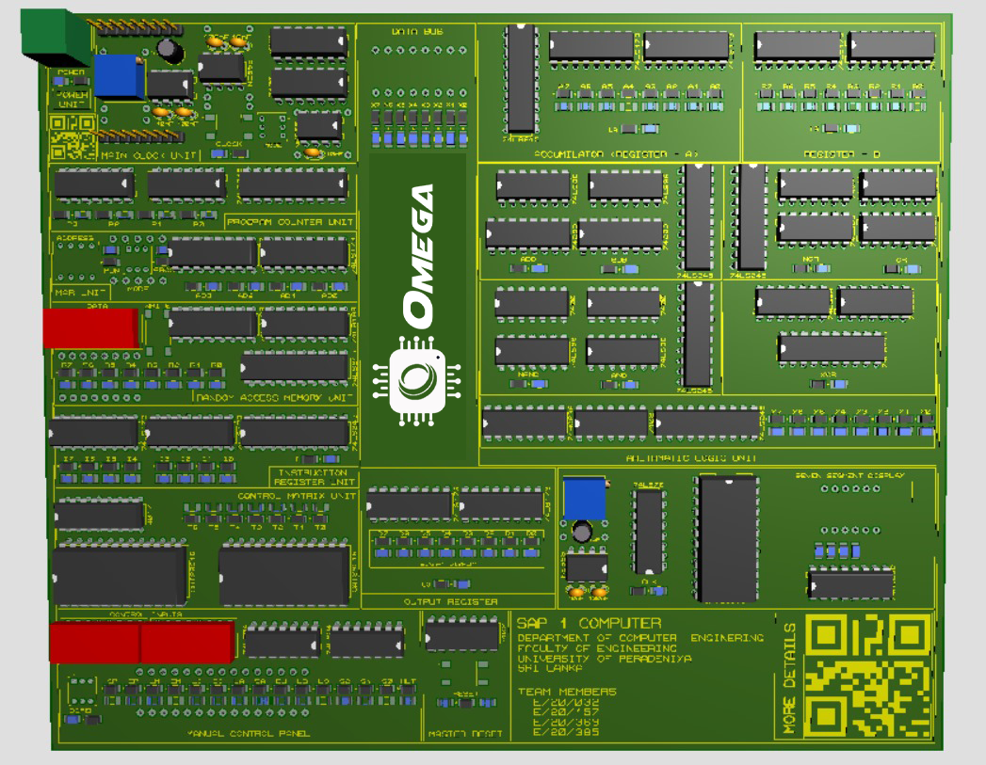

Budget
Item No. | Bill No. | Component | Unit Price | Quantity | Total
01 | 1 | PCB Fabrication |  |  | 20,169.65
02 | 2 | Tax (Shipping /VAT) |  |  | 7,464.00
03 | 3 | Courier charge(Bill 03) |  |  | 480.00
04 | 8 | 74LS00 | 30.00 | 5 | 150.00
05 | 8 | 74LS02 | 30.00 | 4 | 120.00
06 | 6 | 74LS04 | 50.00 | 5 | 250.00
07 | 4 | 74HC08 | 95.00 | 1 | 95.00
08 | 3 | 74LS76 | 120.00 | 2 | 240.00
09 | 3 | 74LS83 | 120.00 | 4 | 480.00
10 | 3 | 74LS86 | 50.00 | 10 | 500.00
11 | 4 | 74LS93 | 60.00 | 1 | 60.00
12 | 4 | 74LS157 | 60.00 | 1 | 60.00
13 | 7 | 74LS173 | 94.25 | 10 | 942.50
14 | 7 | 74LS189 | 226.90 | 5 | 1,134.50
15 | 8 | 74HC238 | 57.50 | 2 | 115.00
16 | 4 | 74LS245 | 26.00 | 10 | 260.00
17 | 9 | 74LS283 | 150.00 | 4 | 600.00
18 | 7 | CAT28C16 | 512.40 | 10 | 5,124.00
19 | 8 | CD4017 | 30.00 | 1 | 30.00
20 | 5 | NE555 | 25.00 | 4 | 100.00
21 | 5 | 7 Segment Display | 56.00 | 2 | 112.00
22 | 4 | LED GREEN (SMD) | 2.25 | 34 | 76.50
23 | 5 | LED-RED (SMD) | 2.50 | 40 | 100.00
24 | 5 | LED-YELLOW (SMD) | 2.25 | 40 | 90.00
25 | 8 | Switch-DPDT | 80.00 | 3 | 240.00
26 | 8 | Self-locking Push Button | 10.00 | 1 | 10.00
27 | 3 | Dip Switch_4 | 30.00 | 2 | 60.00
28 | 5 | Dip Switch_8 | 34.00 | 5 | 170.00
29 | 8 | Resistor 1k | 1.00 | 45 | 45.00
30 | 5 | Resistor 1.2k (SMD) | 1.50 | 120 | 180.00
31 | 3 | 1M Variable Resistor | 8.00 | 4 | 32.00
32 | 4 | Terminal Block I2 | 22.00 | 1 | 22.00
33 | 3 | Capacitor 10nF | 2.00 | 5 | 10.00
34 | 3 | Capacitor 100nF | 2.00 | 5 | 10.00
35 | 3 | Capacitor 1µF | 2.00 | 2 | 4.00
36 | 8 | IC Bases (8 pin) | 5.00 | 4 | 20.00
37 | 8 | IC Bases (14 pin) | 10.00 | 20 | 200.00
38 | 8 | IC Bases (16 pin) | 10.00 | 10 | 100.00
39 | 5 | IC Bases (20 pin) | 7.00 | 10 | 70.00
40 | 5 | IC Bases (24 pin) | 17.00 | 4 | 68.00
41 | 5 | Female Headers | 35.00 | 1 | 35.00
 |  | TOTAL |  |  | 40,029.15

Assembly Language Instructions:
The SAP-1 operates using a simple set of assembly language instructions. These instructions are written in binary code and stored in the RAM. Examples of instructions include:
  - LDA (Load Accumulator): Loads a value from a specific memory address into the accumulator.
  - ADD: Adds the value in the B register to the value in the accumulator.
  - SUB: Subtracts the value in the B register from the value in the accumulator.
  - OUT: Transfers the value from the accumulator to the output register.
  - HLT (Halt): Stops the execution of the program.

Results
The SAP-1 project was successfully completed with all modules functioning as intended. The integration of the modules onto a single PCB resulted in a compact and operational SAP-1 computer. Testing confirmed that the clock module synchronized operations correctly, the program counter accurately tracked instruction execution, and the ALU performed arithmetic and logical operations as expected. The assembly language instructions were executed smoothly, with the output correctly displayed on the output register.

Conclusions and Future Works
The SAP-1 project successfully demonstrated the principles of computer architecture and the step-by-step process involved in building a simple computer. Future improvements could include expanding the instruction set, increasing the memory capacity, and enhancing the ALU to perform more complex operations. Additionally, the development of a more sophisticated control sequencer could allow for more intricate program execution, paving the way for further exploration into computer design.

References
- Mano, M. M. (1992). Computer System Architecture (3rd ed.). Prentice Hall.
- Malvino, A. P., & Brown, J. A. (1996). Digital Computer Electronics (3rd ed.). Glencoe/McGraw-Hill.
- Tocci, R. J., Widmer, N. S., & Moss, G. L. (2011). Digital Systems: Principles and Applications (11th ed.). Pearson.

